Gateway Rifle & Pistol Club hosts an NRA Refuse To Be A Victim® Seminar

Early Saturday morning, Feb 10th, 18 women came together to learn about personal safety and how to make themselves a more difficult target for criminals. They attended a Refuse To Be A Victim® (RTBAV) Seminar, hosted by the Women’s Programs at Gateway Rifle & Pistol Club, and lead by Sue Carter, NRA Certified RTBAV Instructor. RTBAV was developed by the women of the NRA back in 1993, and was originally designed for women only. However, a few years later it was expanded to co-ed audiences. The 4-hour class had not been presented at Gateway for several years.

Topics covered included physical, home, automobile, travel, and technological security, as well as personal protection devices. We delved into the mindset of criminals and then examined our own mindset. The class looked at our everyday activities and talked about how vulnerable we may be at different times. It is important to be mentally prepared for different situations, and to do that means you think about them and how you want to react. It is better to have thought about a strategy ahead of time before a problem stares you in the face. Do you know how you would react? Also, given whatever action you choose, are you aware of the potential consequences that may follow?

Sue presented a wide array of options to make ourselves and our homes less appealing to criminals, and included strategies to minimize confrontations. While there is no “one size fits all” answer to security for all of us, the seminar offered many alternatives. Sue’s display included several low-cost items available at your local hardware stores, from a wide-view peep hole for your front door, to motion sensor lights, to a personal alarm, and much more.

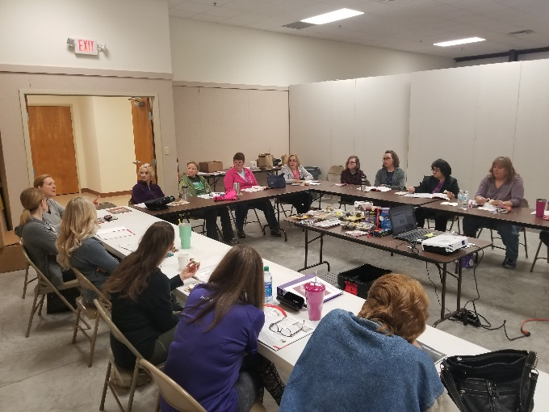
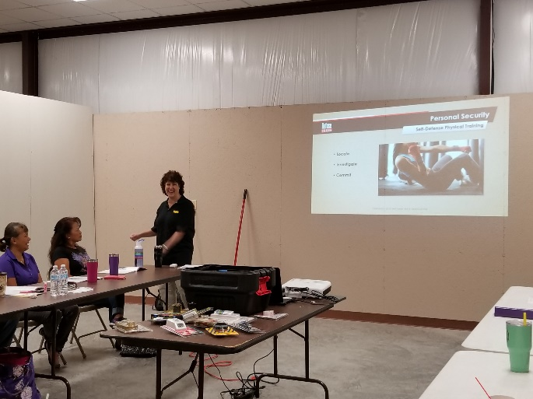
The ladies were very engaged and the discussions lively. Thank you to all who participated, and thank you to Gateway for supporting this program. If you are interested in attending a RTBAV seminar, please contact Sue (suzcarter@reagan.com). If there is enough demand, she will offer another class at Gateway later this year.

